Wipro DSE MILESTONE- 1
Assignment (Normalization)

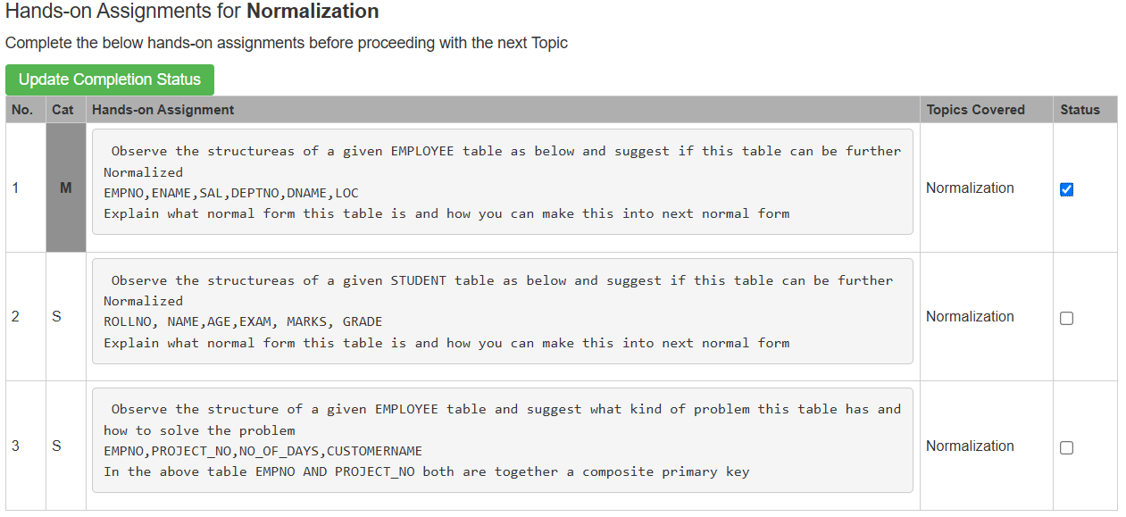
- EMPLOYEE TABLE:
EMPNO, ENAME, SAL, DEPTNO, DNAME, LOC
The EMPLOYEE table is in 2NF because it has a single primary key (EMPNO), and all non-key attributes depend on this key.
Hence, there are no partial dependencies.
But it is not in 3NF due to the transitive dependency- EMPNO → DEPTNO → DNAME, LOC.
CONVERSION TO 3NF:
EMPLOYEE- EMPNO, ENAME, SAL, DEPTNO
DEPARTMENT- DEPTNO, DNAME, LOC

- STUDENT TABLE:
ROLLNO, NAME, AGE, EXAM, MARKS, GRADE

The STUDENT table is in 1NF because all attributes contain atomic values.
But it is not in 2NF because NAME and AGE depend only on ROLLNO which is a part of the composite key ROLLNO, EXAM, causing a partial dependency.
It is also not in 3NF because GRADE depends on MARKS, creating a transitive dependency.

CONVERSION TO 3NF:
STUDENT – ROLLNO, NAME, AGE
RESULT – ROLLNO, EXAM, MARKS
GRADE – MARKS, GRADE

- EMPLOYEE_PROJECT TABLE:
EMPNO, PROJECT_NO, NO_OF_DAYS, CUSTOMERNAME
The EMPLOYEE_PROJECT table is in 1NF because all attributes contain atomic values.
But its not in 2NF because CUSTOMERNAME depends only on PROJECT_NO which is the part of the composite primary key EMPNO, PROJECT_NO, creating a partial dependency.

CONVERSION TO 2NF:
EMPLOYEE_PROJECT – EMPNO, PROJECT_NO, NO_OF_DAYS
PROJECT – PROJECT_NO, CUSTOMERNAME

